Payment Processing

Under Claims Adjustment

1. Summary of Payment Details is read-only. User has to go to Claims Payment Processing Menu to create Payment Approval Request

Under Claims Payment Processing

1. Change search fields: Policy No. to Claim No. / Insured Name to Claimant Name / Remove Organization Country or rename to Claim Type and selection = Own Damage / Property Damage / Bodily Injury. Include Search Field for Claim Type: <<Dropdown – Own Damage / Property Damage / Bodily Injury >>
2. Search Results:

|  |  |  |  |  |  |  |
| --- | --- | --- | --- | --- | --- | --- |
| S/No. | Claim No. | Claimant Name | Claim Type | Accident Date | Vehicle No. | Action |
| 1 |  |  |  |  |  | << Select >> |
|  |  |  |  |  |  |  |

Note: Upon clicking on Select, System will bring user to Payment Processing Screen (similar to screen layout for Claim Registration, all tabs are blocked out except for Payment Tab)

1. Payment Tab Grid:

|  |  |  |  |  |  |  |  |  |
| --- | --- | --- | --- | --- | --- | --- | --- | --- |
| +/- | Claim Type / No. | Claimant Name | Claimant Name | Amount Paid | Payee | Approved Date | Status | Action |
| + | OD |  |  |  |  |  |  |  |
| 🡪 | OD-001 |  |  |  |  |  | << Approved / Rejected >> | << Select >> |
| + | PD |  |  |  |  |  |  |  |
| 🡪 | PD-001 |  |  |  |  |  | << Approved / Rejected >> | << Select >> |
| 🡪 | PD-002 |  |  |  |  |  | << Approved / Rejected >> | << Select >> |
| + | BI |  |  |  |  |  |  |  |
| 🡪 | BI-001 |  |  |  |  |  | << Approved / Rejected >> | << Select >> |
| 🡪 | BI-002 |  |  |  |  |  | << Approved / Rejected >> | << Select >> |

When User clicks on Select, the Relevant Payment Approval Request Screen will appear:

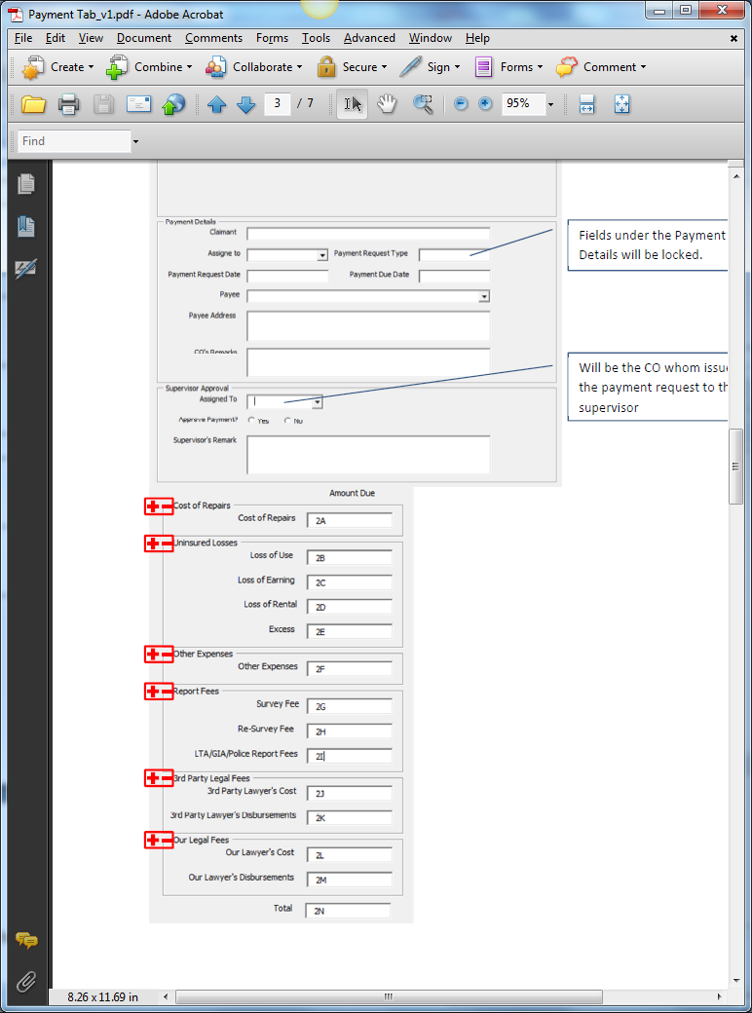

Relevant Fields from Mandate Request Screen.

Include Approved Mandate Column. Read Only. Amount Due is less than or equal to this value. Editable by CO and Supervisor

Address as Address1, Address2, Address3, Postal Code

Populate Created Service Providers

Validate with Supervisor’s FAL

1. Supervisor Approval Section to have Access Rights.
2. Validation: Mandate must be approved and there must be Reserve created before User can create any Payment Approval Request
3. Validation: If Initial Reserve = 0, no Payment is allowed. If Mandate Status is Approved, show Outstanding Amount and Initial Reserve has values, Payment is allowed. If Mandate Status is Pending, show Pending Status. If Mandate Status is rejected, show status as 0. If Mandate is not created, show status as 0.
4. Under Payment Due Date: System is to keep track of this date and when it is expired, system will highlight this entry as red in the Diary Listing. To highlight entry as green 2 days before Expiry Date.